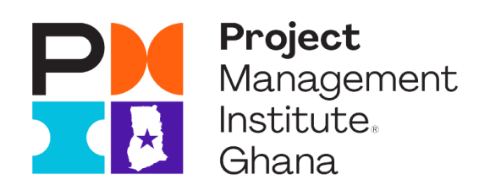
PMI GHANA CHAPTER BOARD OF DIRECTORS

Nominations Form

Please write a 250 word or less response to each of the following questions:

- How do you see PMI Ghana Chapter influencing organizations’ performance and achieving competitive advantage in the market place?

- Demonstrate how you have helped shape strategic objectives and translated them to a vision in your career. Demonstrate how those experiences will enable you to contribute to executing PMI Ghana Chapter’s strategic plan.

- Discuss the benefits of having diverse teams in producing results and provide an example from your career where you enabled diversity.
Potential Nominee Name and Designation(s):

Preferred E-mail address:

Current Professional Employer:

Current Professional Title:

Membership Status:

Insert Digital Photograph:

- Describe the various governing roles you have held in the past.

- Provide a description of your current and past professional experiences (not related to PMI Ghana Chapter). Include your educational and career successes and adversities as well as highlight any public speaking or media interaction you may have had.
- Provide a description of your current and past PMI Ghana Chapter and other volunteer experiences. Include the roles and projects that you were involved in, as well as highlight any public speaking or media interaction you may have had.

